11th Global Microbial Identifier
Program

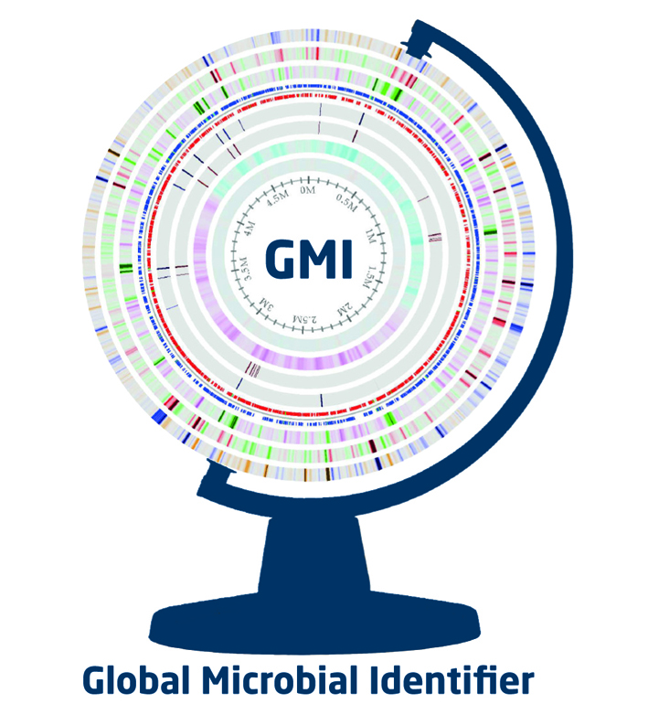

16 - 18 May 2018
Geneva, Switzerland

Day 1: Wednesday 16th May 2018 (Meeting Agenda guided by WHO – Focus on informing Newcomers to Next Generation Sequencing

08:00-09:00 Registration
Next Generation Sequencing
09:00-09:30 | Inauguration
09:30-09:50
09:50-10:10
10:10-10:30
10:30-11:00 Coffee Break
Developing Countries – Novel Potential
11:00-11:20
11:20-11:40
11:40-12:00
12:00-13:30 Lunch
Existing Platforms for Sequencing Analysis
13:30-14:15 | NCBI
14:15-15:00 | EBI
15:00-15:30 | DDBJ
15:30-16:00 Coffee Break
GMI – A future Platform
16:00-16:30
16:30-17:00
17:00-17:30
Conclusion of Day 1

Day 2: Thursday 17th May 2018

08:40-09:00 | Welcome - NGS - The Big Picture
Active Systems and Barriers to International Data Sharing
09:00-09:20
09:20-09:40
09:40-10:00
10:00-10:30 | Discussion Panel Data sharing
10:30-11:00 Coffee Break
Advances in the Use of WGS in Clinical Microbiology and Functional Genomics
11:00-11:20
11:20-11:40
11:40-12:00
12:00-12:20
12:20-14:00 Lunch
Epidemiology, Surveillance and Outbreak investigation using NGS data
13:30-13:50
13:50-14:10
14:10-15:20
16:00-16:30 Coffee Break
GMI Ring tests – Accreditation of NGS Labs
16:30-16:50 | GMI Proficiency Testing – Bacteria and Virus
16:50-17:10
17:10-17:30
17:30-18:00
Conclusion of Day 2
Day 3: Friday 18th May 2018

NGS in One Health – AMR Surveillance and investigation
08:30-09:10
09:10-09:30
09:30-09:50
09:50-10:20 Coffee Break
Metagenomic Analysis of Bacterial Communities
10:20-10:40
10:40-11:00
11:00-11:20
11:20-11:40 | Metagenomics of Plant-Microbial Interactions (EUPHRESCO)
11:40-12:00 | Metagenomics of Environmental-Microbial Interactions
12:00-13:30 Lunch
13:30-15:30 | WG 1-4 Break-out Session
15:30-16:00 Coffee Break
16:00-16:15 | WG1 Outcome
16:15-16:30 | WG2 Outcome
16:30-16:45 | WG3 Outcome
16:45-17:00 | WG4 Outcome
17:00-17:30 | Concluding Discussion
Conclusion of Day 3

